Draft CCDM Trendcare Wellness GDP & National Health Acuity AI strategy discussion paper
The Care Capacity Demand Management (CCDM) programme was developed to ensure safe staffing & healthy workplaces as a national priority in the NZ public health system. CCDM is about matching the capacity to care resourcing with patient demand and needs consistent, focused attention combined with the ability to accurately capture standardised data to match nursing personnel resources with patient acuity to create continuous productivity efficiencies in both health cost and patient outcomes at scale. CCDM is a whole of hospital approach for managing the capacity to care on a permanent basis via Governance Councils with front line staff, managers, executives, health unions and professional leaders all having a role to play. CCDM is about improving patient care, making the best use of resources and providing a better work environment for staff at the front line.
In New Zealand personnel costs account for 2/3 of the District Health Boards Public Hospital system 2016 budget of over $11.7bl per annum or 7.4% of GDP. The CCDM programme has been rolled out across the NZ DHB system nationally. Trendcare is the validated acuity tool to underpin the Care Capacity Demand Management Program (CCDM) and its 5 standards to create a national health efficiency dividend. TrendCare is described as a critical IT system. Costs reductions in labour, improved patient outcomes and associated system efficiency benefits have been shown in some cases to be 10-20%. A 20% efficiency dividend on a $5bl per annum nursing budget could create a $1bl p.a. efficiency dividend or .7% of GDP.
Contents
- Principles/Scope/Description
- Data Governance Councils
- Data Infrastructure, Ownership & Health AI,
- Health AI and Trendcare CCDM
- History
- References
- Links

- Principles/Standards
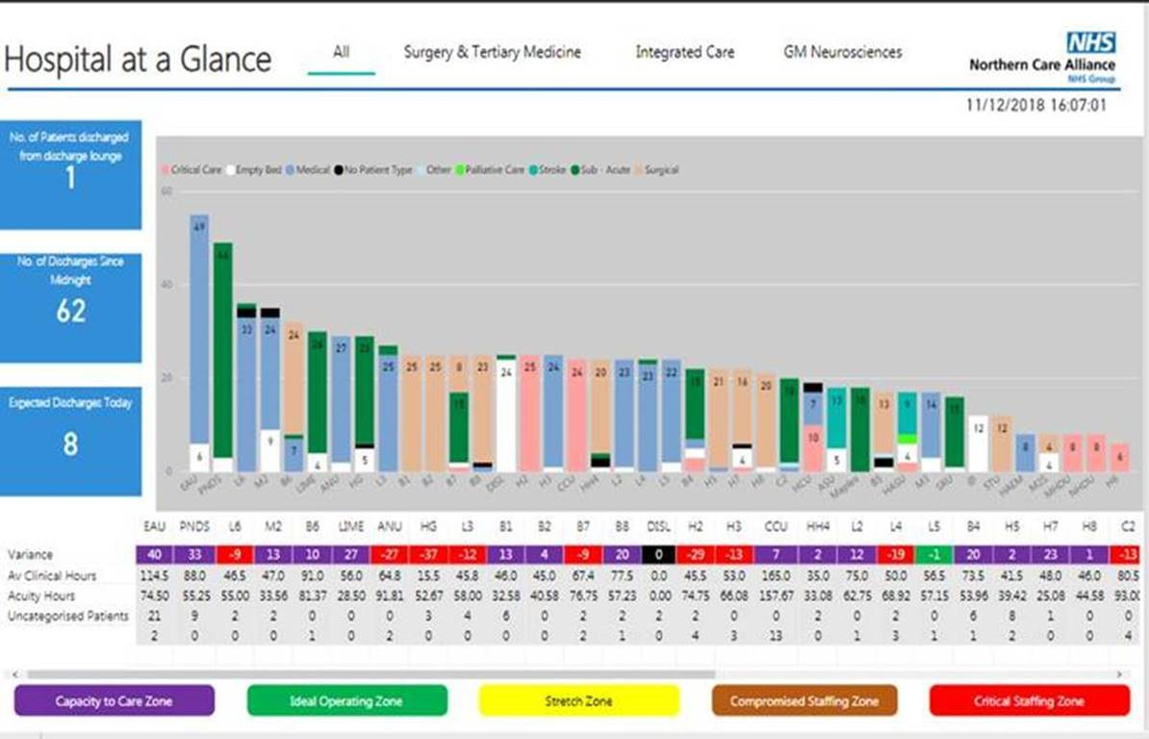
- The CCDM programme work plan covers the 5 standards of the programme –
- Governance – CCDM Governance Councils (organisation & ward/unit) ensure that care capacity demand management is planned, coordinated and appropriate for staff & patients.
- Validated Patient acuity - The validated patient acuity tool underpins care capacity demand management for service delivery
- Core Data Set - uses a balanced set of measures to evaluate the effectiveness of the care capacity demand management overtime for improvements
- Staffing methodology – A systematic process is used to establish and budget for staffing FTE, staff mix, and skill mix to ensure the provision of timely, appropriate safe services.
Need a ccdm report like salford Royal Hospital at a Glance screen using TrendCare data
- Variance response – DHB’s use a variance response management system to provide the right staff numbers, mix and skills at all time for effective patient care.
- TrendCare as the validated acuity system has 5 core principles/processes

- Categories of care – provide a timing value for the correct skill mix and resource allocation
- Patient types – provides a complete map of the Hospital treatment ecosystem
- Indicators – provide a total ingredients mix for each patient type for customising care requirements
- Care Plan – has no defined end as distinct from care paths which have an expected length of stay
- IRR/Inter Reliability Rating - ensures nurses are using the acuity tool properly and provides the timing study framework for continuously adjusting the acuity algorithm for accurate resource allocation. Customised electronic dashboards display real time visibility in all areas of a facility and multi-disciplinary electronic handovers.
A new data governance system - NZ Health CCDM & Local Data Councils
The role of data and its representative governance has never been more important in the age of the digital health system. As part of the program CCDM & Local Data Councils are mandated permanent structures within the public hospital system with responsibility for the governance and maximising the utility value of the data to underpin a health data infrastructure. In 2018 the NZ Director General of Health and Chief Nursing office endorsed the use of TrendCare in all District Health Boards (DHBs) as the validated 2.0 patient acuity “data” tool to enable a national patient acuity standard and the CCDM (Care capacity demand management) programme. This has been achieved in partnership with health unions who are key participants in the Councils and decision making and a core driving force to secure acuity based staffing over ratios.
Data Infrastructure, Ownership & Health AI – The future
Data is becoming a vital new form of infrastructure with trust and ownership being the key issues. The ODI asks the question “What is data infrastructure” and describes data as important as our road, railway, and energy networks and should be treated as such. The focus of the recent Open Data Institute’s (ODI) #Open The role of data in AI business models paper is on the role of data building AI systems, and how access to data, or a lack of access, might impact the creation of value for people, businesses and society.
The potential of targeted AI applications has been estimated by PricewaterhouseCoopers (PWC) as adding up to $15.7 trillion USD to global GDP by 2030, making AI the “biggest commercial opportunity in today’s fast changing economy”. In 2016, Frost and Sullivan found that the application of AI solutions in the healthcare sector has the potential to “improve outcomes by 30 to 40 percent, while cutting treatment costs by as much as 50 percent.”
AI systems are defined as “executable models that take some data input and produce specific recommendations, decisions or actions. They are a combination of statistical and mathematical techniques, an understanding of the world and data”. AI according to the Centre of Public Impact (CPI) can usefully be described as “software that enhances and automates the knowledge-based work done by humans”.
In the recent NHS-Google DeepMind data sharing deal the Royal Free Hospital trust shared up to 1.6 million patients’ data with Google DeepMind, the UK-based artificial intelligence company.
By combining patients’ data, a better understanding of disease can be developed. It’s a combination of resources for greater individual benefit, just like a mutual. Transformative AI’s predictive deep learning models are an example of what is happening in Health AI “treatment” delivery. Their mission is to collect and translate clinical data into real-time, predictive assessments that guide the actions of patients and healthcare providers." The issue of public data controlled by one private company is seen as increasingly problematic and there is an active search for a public data utility alternative which protects user ownership of their data independent of the platform.
The NZ Health CCDM program enabled by the TC acuity platform maps the total acuity care process ecosystem and collects the data to support roster reengineering/variance response & predictive modelling decision making processes. The significant amount of work in establishing this NZ Health “data infrastructure” i.e. access to the patient acuity data combined with a permanent governance structure simplifies the move to a whole of hospital “Transformative AI” predictive capability supporting not only nurse but also key financial management budgeting, operational and government oversight needs real time.
Data Trusts could allay our privacy fears
A UK government commissioned Independent review into artificial intelligence (AI) in 2017 recommended Data Trusts as the way to share data in a fair and equitable way. In practice, a data trust could specify legal terms as well as governance processes and technical mechanisms of data access. It’s a combination of resources for greater individual benefit, to manage the assets on behalf of the members just like a mutual.
The UK NHS recognises the principle of patient ownership of data, but in practice it balances that with the wider “patient interest”. NH Trust Boards, compelled to operate within the “Trustee” constraints of the “data trust” contract they formed with their members, are seen as is a way to derive the mutual benefit, just like in a land society whilst protecting the principle of patient ownership of data.
Health AI and CCDM programme’s AI opportunity
The NZ CCDM Trendcare program creates a Health Data Infrastructure with permanent governance structures and data assets that can underpin a Health AI data trust system which “enhances and automates the knowledge-based work done by humans” as its natural next evolutionary step. The NZ CCDM Data Governance roadmap provides a templated Data Council implementation program which could be applied by any Hospital or health Board/Trust. The CCDM Council & Local Data Council organisational system could be adapted as a generic data governance process/framework to any Community, Industry & Business “data infrastructure-AI governance” requirement.
The CommunityLink Open Data Ecology (CODE) paper introduces a Data Commons/Public Data Utility model to create i. Data infrastructure enabling user data ownership ii. an interconnected network ecosystem of Data Trusts/Mutual Asset Pools to manage the assets on behalf of the members iii. User established governance in perpetuity. Core to this governance is a Legal Partnership framework for “Data Councils/Campuses” governance to evolve a dynamic constitution i.e. “CommunityLink Trust” which supports collective AI intelligence (sense) with permanent human oversight.
Neil Lawrence (Director of machine learning, Amazon Research Cambridge and professor of machine learning, University of Cambridge talks of “an ecosystem of data trusts which would enable co evolution of regulation and the greater democratization of the data landscape. The ODI states that “Data is not treated as infrastructure. We need to change this.” Trustworthy data infrastructure is sustainably funded and it is directed to maximize data use and value to meet society’s needs.
The national NZ DHB ecosystem of permanent Data Council governance from Local Data Council/ ward level up combined with Trendcare CCDM software acuity algorithm and ability to capture standardized data underpins
- The NZ CCDM Default Progressive Expenditure reduction (DPER) program underway with a potential 0.7% of GDP national efficiency dividend to sustainably fund the national health “data infrastructure” via the efficiencies created
- Improved patient outcomes with improved health in the community and associated community, business, government cost savings & efficiency benefits.
- The ability to establish a National NZ Health Access public data utility/AI enhanced network with Data Council/Trustee, AI/Data Trust Governance, which is recreatable globally in health initially and ultimately to meet other Community and industry sector (public utility) data infrastructure needs.
The Capital & Coast DHB letter of Agreement to establish their CCDM program which states what each party is responsible for, how they will work together and what the expected outcomes provides the start point to define a path and agreement to transition to DHB Health AI, public data utility network system.

History
In 2005 a Committee of Inquiry identified the aims and elements of safe staffing. The Committee was made up of District Health Boards, New Zealand Nurses Organisation, Ministry of Health and an independent chair. The Safe Staffing Healthy Workplace Unit was established to facilitate the implementation of the recommendations from the Inquiry. One of the key functions of the Unit was to develop the CCDM programme and support change. The CCDM programme has evolved from the ground up over the past 10+ years.
Gallery
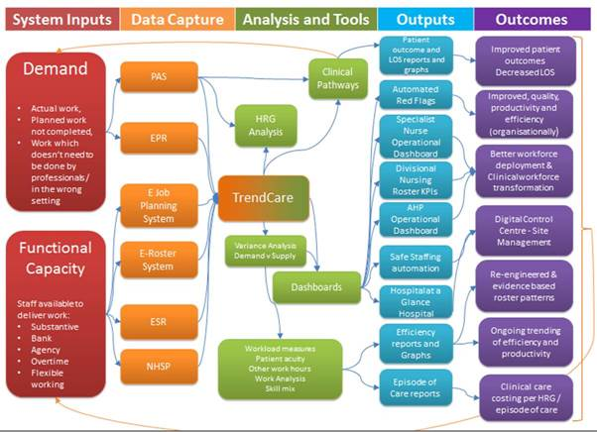
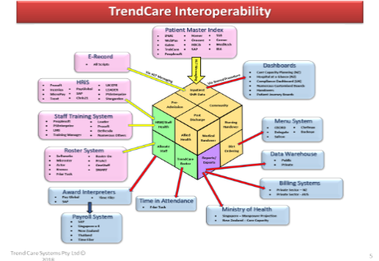

Need CCDM visuals/reports to replace these diagram

References – some suggestions to support the TC global std/national solution enabler
1. CCDM Councils How the CCDM program uses TrendCare – NZ CCDM DHB standard Governance package
2. TrendCare key performance Indicators form. This CCDM form is used by the clinical manager (and their manager) to show that TrendCare data is being monitored, used and improved on a day to day basis.
3. “Skill mix changes for our nursing workforce and working pattern changes delivered by Trendcare implementation”. Operational Plan Document for 2016/17 Salford Royal NHS Foundation Trust
4. “Use of Workforce Repository and Planning Tool (WRaPT) and Trendcare systems to review skill mix”. Operational Plan for 2017/18 and 2018/19 Salford Royal NHS Foundation Trust
5. “Workforce planning & Workload Management System”. Evaluation of the ‘Pilot Implementation of the Framework for Safe Nurse Staffing and Skill-Mix’ Report 3 Pilot Wards January 2018
6. ‘AI to drive GDP gains of $15.7 trillion with productivity, personalisation improvements’, PricewaterhouseCoopers (2017),
7. ‘From $600m to $6bn, Artificial Intelligence Systems Poised for Dramatic Market Expansion in Healthcare’, Frost & Sullivan (2016),

External Links
- NZ CCDM program
- Capital & Coast DHB CCDM

